**Guiding Principles for Agency Wellness Initiative:**

We believe that wellness is a result of balance among all dimensions of well-being: spiritual, physical, social, emotional, intellectual, environmental, occupational and financial

Child-Parent Centers, Inc. strives to create an environment that promotes wellness in the context of daily life practices and choices through education, increasing awareness, and strategic actions

The agency’s approach to wellness and plan for increasing wellness is intentional and flexible to meet individual needs and supports positive exchange with others

We will encourage experiences to promote wellness that are fun, engaging, and build upon intrinsic motivation

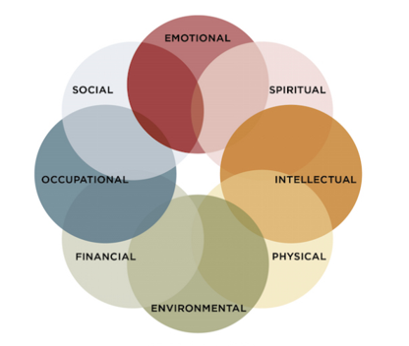

Eight Dimensions of Wellness, Substance Abuse and Mental Health Services Administration (2017). Retrieved from: https://www.samhsa.gov/wellness-initiative/eight-dimensions-wellness

EIGHT DIMENSIONS OF WELLNESS